**A ROBUST LIFI-LIDAR COMMUNICATION SYSTEM ENSEMBLEDWITH DRONE ASSEMBLY**



Institution Entrepreneurship Development Cell, Institute of Engineering & Management, Kolkata

By

Kaustav Laskar

Debmalya Das

Rajdeep Biswas

Subham Das

Under the guidance of

**Dr. Priti Das**

Signature of the Mentor Signature of the Head of

the Department

**ABSTRACT**

Natural disasters pose significant threats to communities worldwide, necessitating efficient and rapid disaster management solutions Disaster management drones with lidar modules are becoming increasingly popular, as they offer a number of advantages over traditional methods of disaster assessment and response. Drones are able to access remote and dangerous areas that would be difficult or impossible for humans to reach, and they can provide real-time information to rescuers and other decision-makers. A cutting-edge Disaster Management Drone equipped with a LiDAR (Light Detection and Ranging) module, designed to revolutionize disaster response and recovery efforts. LiDAR technology enables the drone to capture high-resolution, three-dimensional terrain data, offering detailed insights into disaster-stricken areas. The drone's swift deployment, coupled with LiDAR capabilities, empowers emergency responders and relief organizations to make informed decisions, prioritize resources, and strategize rescue operations effectively.

Here are some specific examples of how lidar-equipped drones have been used in disaster management: In the aftermath of the 2011 Tohoku earthquake and tsunami, drones were used to assess the damage to nuclear reactors and other critical infrastructure. In 2017, drones were used to search for survivors in the aftermath of Hurricane Harvey. In 2018, drones were used to map the damage caused by the Camp Fire in California.

Overall, disaster management drones with lidar modules are a valuable tool for rescuers and other decision-makers. Drones can be deployed quickly and easily to access remote and dangerous areas, and lidar modules allow them to create accurate 3D maps of their surroundings. This information can be used to assess damage, identify survivors, and plan rescue operations. As drone technology continues to develop, it is likely that lidar-equipped drones will play an even greater role in disaster management in the future.

**ACKNOWLEDGEMENT**

We express our profound gratitude and indebtedness to Dr. Priti Das, Prof. Dibakar RoyChoudhury, Mr. Arghya Roy of IIIC-IEDC Lab, Institute of Engineering & Management, Kolkata for introducing the present topic and for their inspiring guidance, constructive criticism, and valuable suggestion throughout the project work.

We wish to convey our sincere thanks to all faculty members who have patiently extended all sorts of help in accomplishing this undertaking.

Date:

Kaustav Laskar Debmalya Das

Rajdeep Biswas Subham Das

**TABLE OF CONTENT**

**CHAPTER 1**

**1.1 INTRODUCTION………………………………………..…….……………….06**

**CHAPTER 2**

**2.1 BACKGROUND RESEARCH…………………………………………………07**

**CHAPTER 3**

**3.1 PROJECT DESCRIPOTION……………………………………………..……08**

**3.1.1 HARDWARE DESCRIPTION……………………………....………09**

**3.1.1.1 BLDC Motor…………………………………...…..………..08**

**3.1.1.2 Electronics Speed Controller……………….…………..…..08**

**3.1.1.3 Drone Frame……………………………….................……..09**

**3.1.1.4 Propeller…………………………………………...…….…..09**

**3.1.1.5 Battery………………………………...…………………..…09**

**3.1.1.6 Flight Controller……………………………………..…..….10**

**3.1.1.7 Remote Controller………………………………………..…10**

**3.1.1.8 Receiver……………………………………...…………..…..10**

**3.1.1.9 GPS Module……………………………………………..…..11**

**3.1.1.10 STM32 Nucleo u575i Zi ……………………...................…11**

**3.1.1.11 LCD Display…………………………………………….….12**

**3.1.1.12 LDR Module………………………………...……………...12**

**3.1.1.13 13 Buzzer………………………………………..………….12**

**3.1.2 CONNECTION DIAGRAM……………………………..…………...13**

**3.1.3 SOFTWARE DESCRIPTION……………………….…………….…14**

**3.1.3.1 QGroundControll……………………...……………………14**

**3.1.3.2 Mission Planner……………………..…………………….....14**

**3.1.3.3 Software IDE…………………………………………….…..15**

**CHAPTER 4**

**4.1 IMPLEMENTATION………………………………………….……………….16**

**CHAPTER 5**

**5.1 FUTURE SCOPE……………………………………………………………….17**

**CHAPTER 6**

**6.1 CONCULSION………………………………………………………………….18**

**CHAPTER 7**

**7.1 REFERENCE………………………………………………………..……….…19**

**TABLE OF FIGURE**

**CHAPTER 3**

**3.1 PROJECT DESCRIPOTION………………………….…………………….…08**

**3.1.1 HARDWARE DESCRIPTION………………………………....……08**

**3.1.1.1 Fig No 1 BLDC Motor……………………………..………..08**

**3.1.1.2 Fig No 2 Electronics Speed Controller……………….……..08**

**3.1.1.3 Fig No 3 Drone Frame………………………………...……..09**

**3.1.1.4 Fig No 4 Propeller……………………………………….…..09**

**3.1.1.5 Fig No 5 Battery………………………………...……………09**

**3.1.1.6 Fig No 6 Flight Controller………………………………..….10**

**3.1.1.7 Fig No 7 Remote Controller…………………………………10**

**3.1.1.8 Fig No 8 Receiver……………………………………...……..10**

**3.1.1.9 Fig No 9 GPS Module………………………………………..11**

**3.1.1.10 Fig No 10 STM32 Nucleo u575i Zi ……………………...…11**

**3.1.1.11 Fig No 11 LCD Display…………………………………….12**

**3.1.1.12 Fig No 12 LDR Module………………………………...…..12**

**3.1.1.13 Fig No 13 Buzzer………………………………………..….12**

**3.1.2 CONNECTION DIAGRAM…………………………...………..……13**

**3.1.2.1 Fig No 14 Pixhawk Connection Diagram………………..…13**

**3.1.2.2 Fig No 15 STM32 Connection Diagram………………….…13**

**3.1.3 SOFTWARE DESCRIPTION…………………………………….…14**

**3.1.3.1 Fig No 16 QGroundControll Interface……………………14**

**3.1.3.2 Fig No 17 Mission Planner Interface……………………....14**

**INTRODUCTION**

Natural and man-made disasters, such as earthquakes, floods, wildfires, and industrial accidents, have devastating impacts on communities, infrastructure, and the environment. Rapid and effective response during and after these events is crucial for saving lives and minimizing damage. In recent years, advancements in technology have led to the development and integration of unmanned aerial vehicles (UAVs), commonly known as drones, into disaster management strategies.

Disaster management drones are specially designed UAVs equipped with various sensors and technologies to assist emergency responders, relief organizations, and authorities in efficiently managing and mitigating the aftermath of disasters. These drones are capable of capturing high-resolution imagery, conducting aerial surveys, and collecting vital data from disaster-stricken areas, which is instrumental in decision-making processes.

The integration of drones in disaster management brings several key advantages. Firstly, drones can access areas that are difficult or dangerous for humans to reach, providing real-time aerial views of the disaster site. Secondly, they are equipped with advanced sensors, such as cameras, thermal imaging devices, LiDAR modules, and gas detectors, enabling them to gather diverse and valuable data. This data aids in search and rescue operations, damage assessment, hazard identification, and resource allocation

**BACKGROUND RESEARCH**

Unmanned aerial vehicles (UAVs), more commonly referred to as drones, are small aircraft that fly autonomously. Originally developed for military purposes, they are now a major focus of research. Apart from unmanned aerial vehicles, drones are also referred to as UAS (Unmanned Aerial Systems), Remotely Piloted Vehicles (RPV), and Remotely Piloted Aircraft Systems (RPAS). Drones are available for a variety of applications and can be used for crime scene surveillance [1], crop monitoring [2], and vegetation mapping [3].

Recently, the application of drones to disaster or humanitarian relief has expanded to include search and rescue missions [4] disaster prevention [5] and disaster management [6]. When a disaster strikes, a rapid and effective response is critical to assisting the populace, reducing the number of victims, and mitigating the economic impact. Regardless of the type of disasters or emergencies that occurred, disaster management is defined as a process or practice that includes mitigation, preparedness, response, and recovery [7].

Accurate data collection may be extremely difficult in an emergency situation due to the lack of coordinated actions by various agencies during a disaster [8]. Nonetheless, it has been suggested that in order to improve disaster management efficiency, new methodologies and technologies are required to conceptualize systems that incorporate a combination of telecommunication tools, remote sensing, and spatial/ temporal-oriented databases [9].

Thus, the use of drones in a disaster has the following benefits: they reduce the time required to locate victims and the time required for subsequent intervention by searching a large area in a short period of time, in addition to providing critical information to rescuers about the route that needs to be taken during search and rescue operations [10]. Additionally, drones are capable of searching for alive victims buried beneath rubble using sensors such as noise sensing, binary sensing, vibration, and heat sensing [8]. These demonstrate the benefits of having drones on-site during disasters and the capability of drones as critical tools for acquiring aerial images.

**PROJECT DESCRIPTION**

**HARDWARE DESCRIPTION**

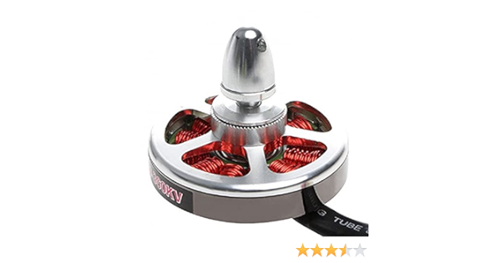A drone, also known as an Unmanned Aerial Vehicle (UAV), is a sophisticated piece of technology comprising various hardware components that enable it to fly and perform specific tasks autonomously or under remote control. Here's a breakdown of the essential hardware components typically found in a drone:

* **BLDC MOTOR :** This 5010 750KV High Torque Brushless Motor for Drone comes with self-cooling technology, so they will be able to withstand high temperatures up to 140° C (356 F). The motor can produce thrust up to 1500 gm on a 4s Lipo battery. This brushless motor for the Drone is evaluated by the high torque offered by them. The motor gives an awesome flight experience on behalf of the NdFeB magnets and properly lubricated high-quality ball bearings.

Fig No: 1

* 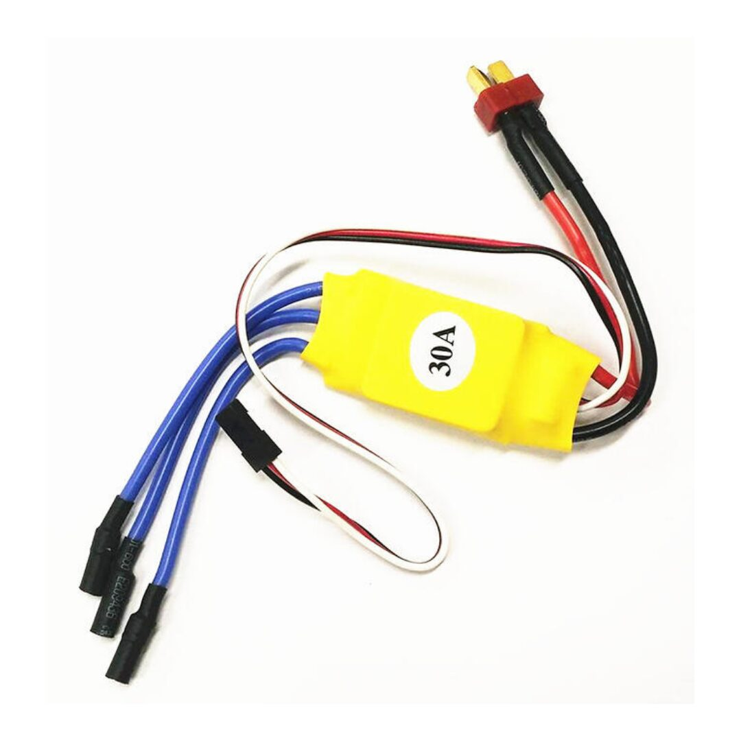**Electronics Speed Controller (ESC)** : Electronic Speed Controller is a crucial component in drone technology, controlling the speed and direction of the brushless motors that power the drone's propellers. ESCs regulate the speed and rotation direction of the brushless motors. By adjusting the voltage and current supplied to the motors, ESCs control the speed of the propellers, enabling the drone to ascend, descend, hover, or change directions. ESCs interpret the control signals received from the flight controller or pilot's transmitter, translating them into specific motor commands. These commands dictate the rotational speed and direction required for the drone's desired movement. We use 30amps ESC in this project.

Fig No: 2

* 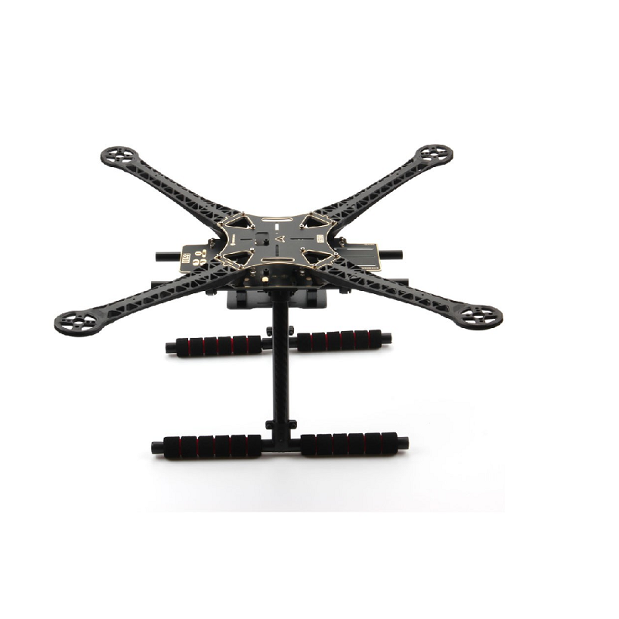**DROEN FRAME : T**his S500 frame is made from Glass Fiber which makes it tough and durable. It has the  arms of ultra-durable Polyamide-Nylon which are the stronger molded arms having a very good thickness so no more arm breakage at the motor mounts on a hard landing. The arms have support ridges on them, which improves stability and provides faster forward flight. The S500 has strong, light, and have a sensible configuration including a PCB(Printed Circuit Board) with which we can directly solder our ESC’s to the Quadcopter. So, making the Quadcopter build fast and easy. So, it avoids the use of extra PDB(Power Distribution Board) and makes the mounting clean and neat. The S500 Quadcopter Frame is highly flexible frame during mounting of various components like flight controller, battery, etc.

Fig No: 3

* 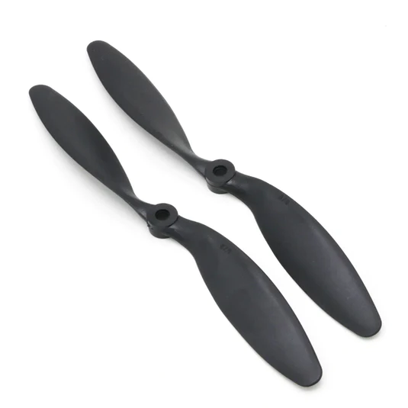**PROPELLERS :** Drones are equipped with multiple propellers (usually four or more) that provide the necessary lift for flight. Propellers can vary in size and pitch, affecting the drone's stability and maneuverability. There are two types of propellers : clockwise & counter clockwise propellers, to balance out all the x and y forces acting on the quad. This way when all the x y forces are equalized, the quad rises up straight depending on the speed on the rotors.

Fig No: 4

* 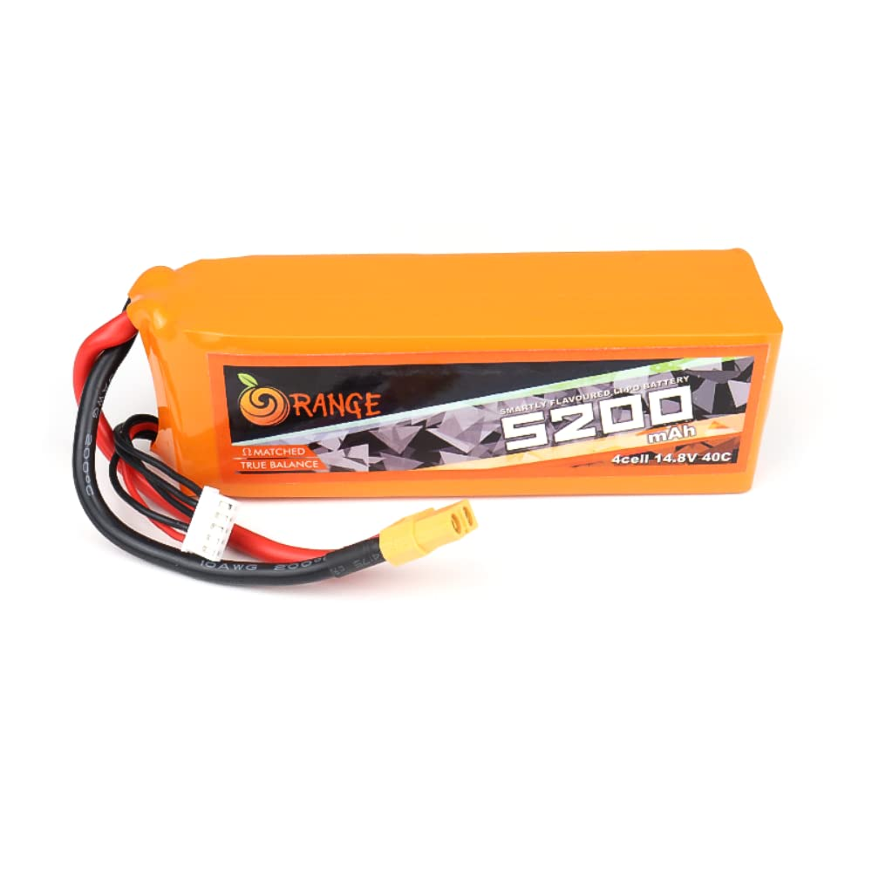**BATTERY :** The ORANGE 5200mAH 4S 40C (14.8V) LiPo battery pack with an XT60 connector is equipped with heavy-duty discharge leads to minimize resistance and sustain high current loads. The ORANGE 5200mAH 4S 40C (14.8V) LiPo battery pack with XT60 connector have a JST-XH style balance connectors. All Orange Lithium Polymer batteries packs are assembled using IR matched cells. Orange batteries are known for performance, reliability, and optimum price also.

Fig No: 5

* 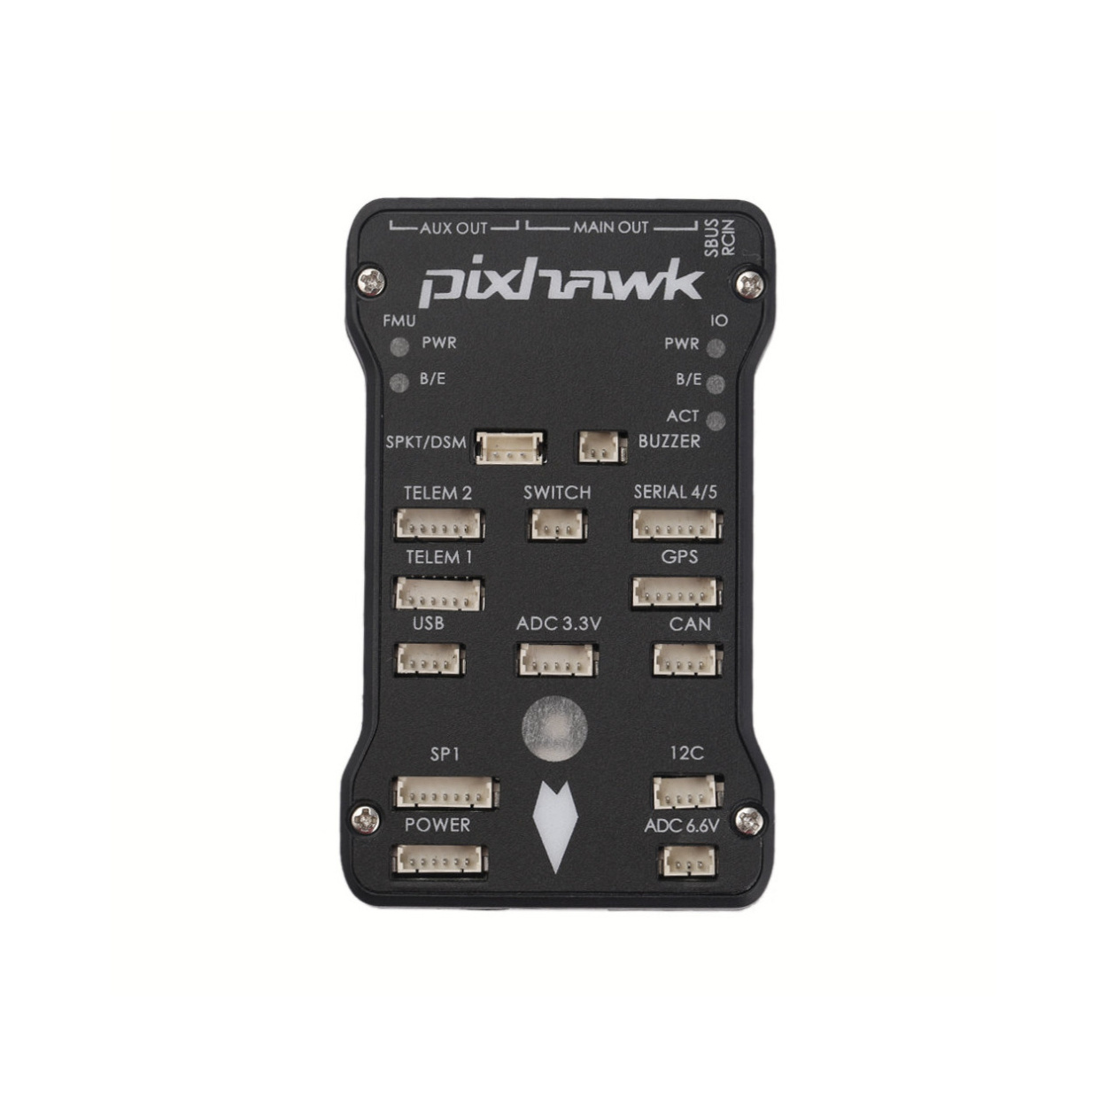**FLIGHT CONTROLLER :** Pixhawk is an open-source hardware and software platform for developing advanced drones and unmanned aerial vehicles (UAVs). It serves as the autopilot system for these vehicles, providing capabilities for stable flight, GPS-based navigation, autonomous mission planning, and more. Pixhawk is widely used in the drone industry, both by hobbyists and professionals, due to its flexibility, reliability, and extensive community support. Pixhawk includes a microcontroller unit (MCU), sensors (such as accelerometers, gyroscopes, magnetometers, and barometers), GPS module, and various input/output ports. The hardware is designed to be robust and capable of handling complex flight tasks.

Fig No: 6

* 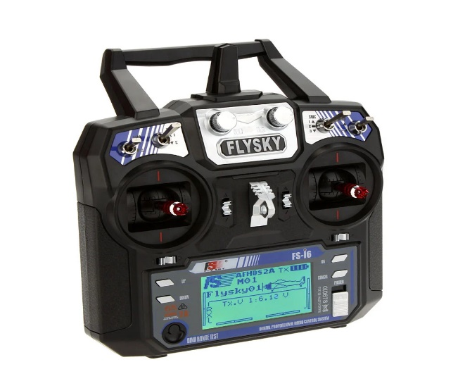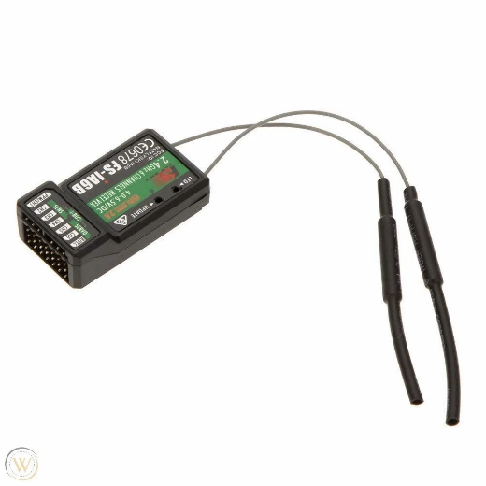**REMOTE CONTROLLER :** FlySky FS-i6 2.4G 6CH AFHDS RC Transmitter with FS-iA6 Receiver (with LCD Display) is a great low cost entry level 6-channel 2.4 GHz Transmitter and Receiver that uses solid and reliable Automatic Frequency Hopping Digital System (AFHDS) spread spectrum technology. It also comes with a FS-iA6 6-channel receiver. This is Suitable for controlling Quadcopters, Multirotor, Heli, and Airplane. FlySky FS-i6 works in the frequency range of 2.405 to 2.475 GHz. This band has been divided into 142 independent channels; each radio system uses 16 different channels and 160 different types of hopping algorithm. This radio system uses a high gain and high quality multi directional antenna; it covers the whole frequency band. Associated with a high sensitivity receiver, this radio system guarantees a jamming free long range radio transmission.

Fig No: 8

Fig No: 7

* 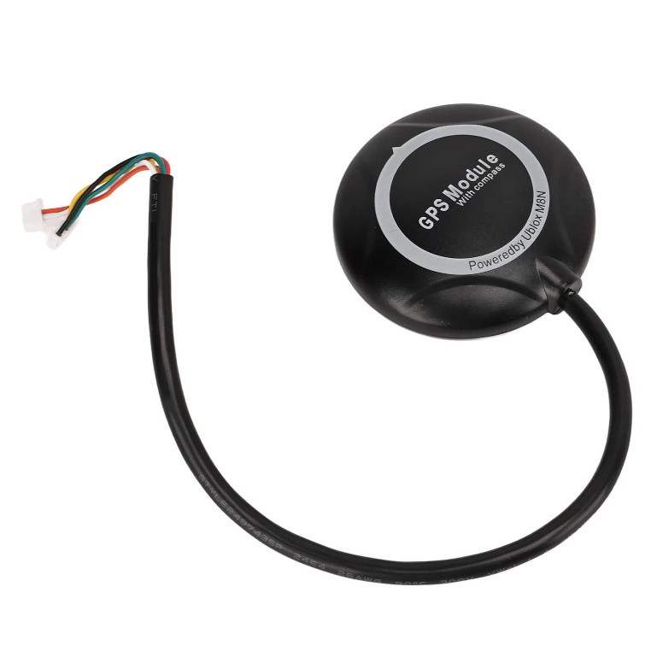**GPS MODULE** : Neo 7M GPS module that includes an HMC5883L digital compass.  The new NEO 7 series is a high sensitivity, low-power GPS module that has 56 channels and outputs precise position updates at 10Hz.  This GPS module also comes in a molded plastic case which keeps the module protected against the elements making it ideal for use on your aircraft or quadcopter. This Neo 7M GPS module uses an active circuitry ceramic patch antenna to provide an excellent GPS signal which outperforms the older Neo 6 series modules.   This Neo 7 module also includes a rechargeable backup battery to allow for HOT starts and also includes an I²C EEPROM to store the configuration settings. This GPS module is configured to run at 38400 Baud and is configured to run with APM/Pixhawk systems.  This GPS module includes two cables, a 6pin connector for the GPS module, and a 4 pin connector for the i2c compass.

Fig No: 9

* 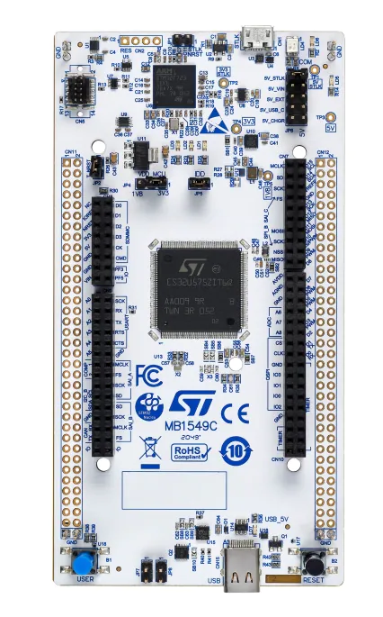**NUCLEO u575zi-Q :** The STM32 Nucleo-144 board provides an affordable and flexible way for users to try out new concepts and build prototypes by choosing from the various combinations of performance and power consumption features, provided by the STM32 microcontroller. For the compatible boards, the internal or external SMPS significantly reduces power consumption in Run mode. The ST Zio connector, which extends the ARDUINO® Uno V3 connectivity, and the ST morpho headers provide an easy means of expanding the functionality of the Nucleo open development platform with a wide choice of specialized shields.The STM32 Nucleo-144 board does not require any separate probe as it integrates the ST-LINK debugger/programmer.The STM32 Nucleo-144 board comes with the STM32 comprehensive free software libraries and examples available with the STM32Cube MCU Package

Fig No: 10

* 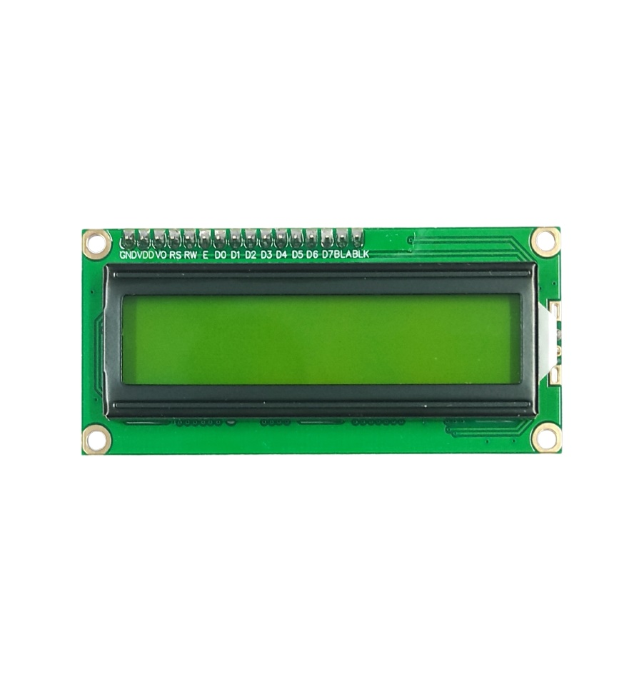**I2C­­ LCD DISPLAY MODULE :** The I2C LCD component is used in applications that require a visual or textual display. This component is also used where a character display is needed but seven consecutive GPIOs on a single GPIO port are not possible. In cases where the project already includes an I2C master, no additional GPIO pins are required.

Fig No: 11

* 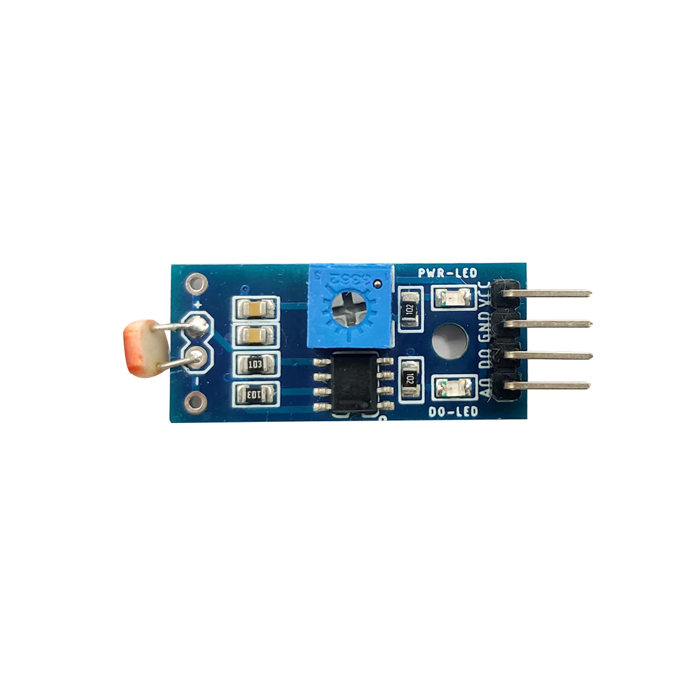**LDR MODULE :** This LM393 Photosensitive Light-Dependent Control Sensor LDR Module is using a high-quality LM393 voltage comparator. Easy to install using the sensitive type photosensitive resistance sensor the comparator output signal gives a clean and good waveform. Driving ability is 15mA with the adjustable potentiometer, it can adjust the brightness of the light. Working voltage is 3. 3V to 5v. Where output is a digital switch output.

Fig No: 12

* 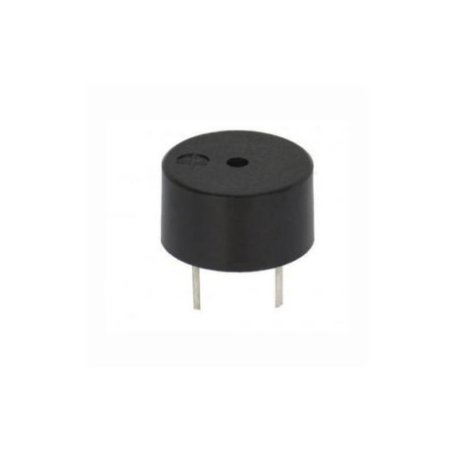**BUZZER :** An audio signaling device like a beeper or buzzer may be electromechanical or piezoelectric or mechanical type. The main function of this is to convert the signal from audio to sound. It includes two pins namely positive and negative. The positive terminal of this is represented with the ‘+’ symbol or a longer terminal. This terminal is powered through 6Volts whereas the negative terminal is represented with the ‘-‘symbol or short terminal and it is connected to the GND terminal.

Fig No: 13

**CONNECTION DIAGRAM**

* 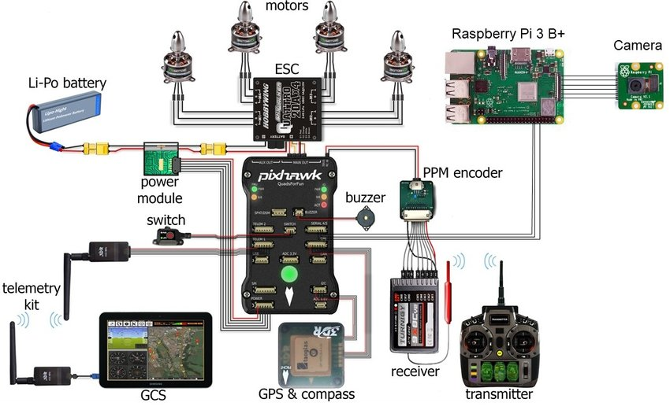**PIXHAWK CONN ECTION DIAGRAM :**

Fig No: 14

* **STM32 CONNECTION :**

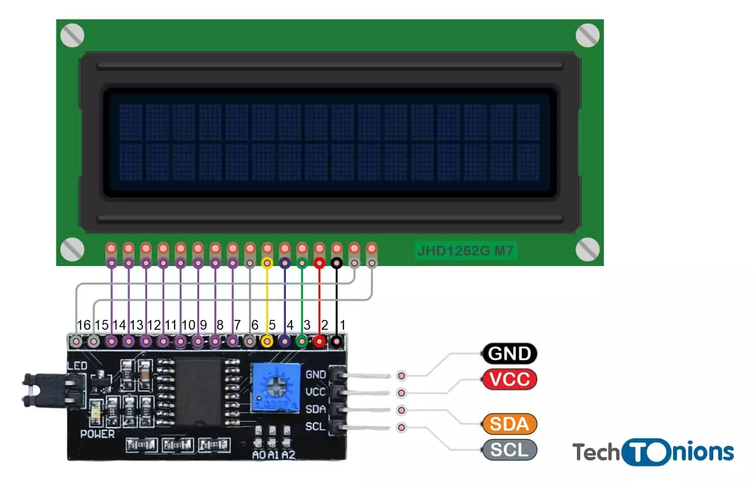

STM32

Fig No: 15

BUZZER

LDR

I2C LCD

**SOFTWARE DESCRIPTION**

* 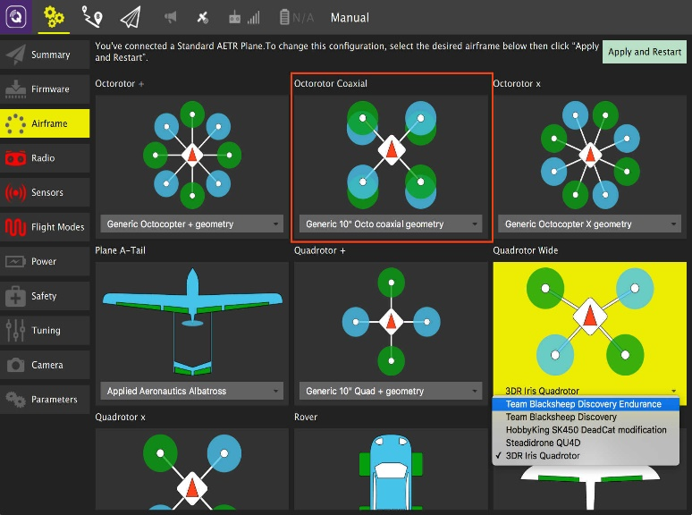**QGROUND CONTROLL :** QGroundControl is an open-source software application used to control unmanned vehicles, primarily drones and robots. It provides a user-friendly interface for configuring, controlling, and monitoring these vehicles. QGroundControl supports a wide range of vehicles, including fixed-wing aircraft, submarines etc.

Fig No: 16

* **MISSION PLANNER :** Mission Planner is a popular open-source ground control station (GCS) software for planning, monitoring, and controlling unmanned vehicles, primarily drones and autonomous aircraft. Similar to QGroundControl, Mission Planner provides a user-friendly interface for configuring vehicles, planning flight missions, and monitoring real-time telemetry data. It is specifically designed for vehicles that use the ArduPilot autopilot system, which includes a wide variety of drones.\

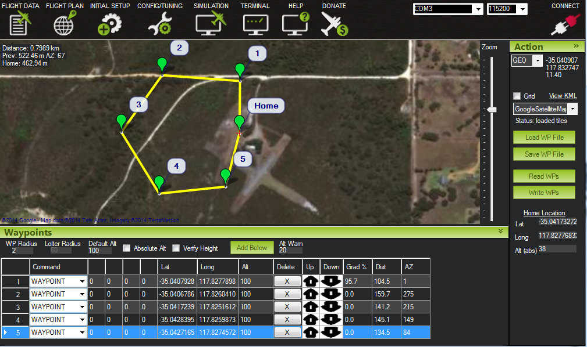

Fig No: 17

* **SOFTWARE IDE :** For this project we have used STM Cube IDE and Arduino IDE for code development of Nucleo u757-Zi. The ldr communication system of the drone developed by using this ide.

Fig No: 18

**IMPLEMENTION**

We use this drone as a replica model top demonstrate how we can autonomously fly a drone and how we established communication through light. We also use lidar module for 3D mapping and ir sensor for object distance detection.

**FUTURE SCOPE**

* **AUTONOMOUS SEARCH AND RESCUE :** Drones equipped with artificial intelligence (AI) and advanced sensors will be able to search for and rescue victims in disaster zones autonomously, without the need for human intervention. This will make search and rescue operations safer and more efficient, especially in dangerous or inaccessible areas.
* **REAL TIME DAMAGE ASSESDMENT:** Drones with high-resolution cameras and other sensors will be able to provide real-time damage assessment of disaster zones. This information will be invaluable to emergency responders, helping them to prioritize their efforts and allocate resources effectively.
* **DELIVERY OF MEDICAL SUPPLIES:** Drones can be used to deliver essential supplies, such as food, water, and medicine, to disaster zones quickly and efficiently, even in remote or inaccessible areas. This can help to reduce the suffering of victims and save lives.
* **COMMUNICATION AND COORDINATION :** Drones equipped with loudspeakers and communication systems can be used for public announcements, providing real-time information to affected communities. They can also assist in search and rescue operations by broadcasting messages to locate missing persons
* .**POST-DIASASTER RECOVERY :** Drones can be used to support post-disaster recovery efforts in a variety of ways, such as mapping damage, monitoring reconstruction progress, and assessing environmental hazards.
* **PREDICTIVE ANALYTICS AND MODELLING :** Disaster management drones can collect vast amounts of data over time, which can be utilized for predictive analytics and modelling. By analysing historical data and disaster patterns, authorities can anticipate potential risks, plan evacuation routes, and allocate resources more effectively.

**CONCLUSION**

In conclusion, the integration of drones, especially those equipped with advanced technologies like LiDAR modules, into disaster management efforts represents a significant leap forward in enhancing the effectiveness and efficiency of disaster response and recovery operations. These drones have the potential to revolutionize the way we prepare for, respond to, and recover from disasters.

By providing real-time, high-resolution data, disaster management drones equipped with LiDAR technology enable emergency responders and relief organizations to make more informed decisions. They offer invaluable insights into disaster-stricken areas, allowing for accurate damage assessment, identification of hazards, and prioritization of resources. The ability to create detailed 3D maps of affected areas enhances situational awareness and aids in strategic planning, ensuring that resources are deployed where they are needed the most.

Moreover, disaster management drones significantly reduce response time, allowing for swift deployment in hard-to-reach or dangerous areas. They can be deployed rapidly after a disaster strikes, providing an immediate aerial view of the affected region. This rapid response capability is crucial in search and rescue operations, where every moment counts in saving lives.

Additionally, the use of drones in disaster management contributes to the safety of emergency responders. By providing aerial reconnaissance, drones can identify potential risks and hazards, allowing responders to plan their interventions more safely and effectively. This technology minimizes the need for responders to enter dangerous or unstable areas, reducing the overall risk to their lives.

In essence, disaster management drones, especially those equipped with LiDAR modules, have the capability to transform disaster response efforts by providing timely, accurate, and actionable information. As technology continues to advance, these drones will play an increasingly pivotal role in mitigating the impact of disasters, saving lives, and aiding in the recovery of affected communities.

**REFERENCE**

1. A. Bucknell, T. Bassindale, An investigation into the effect of surveillance drones on textile evidence at crime scenes, Sci. Justice 57 (5) (2017) 373–375.
2. J. Bendig, A. Bolten, S. Bennertz, J. Broscheit, S. Eichfuss, G. Bareth, Estimating biomass of barley using crop surface models (CSMs) derived from UAV-based RGB imaging, Remote Sensing. 6 (2014) 10395–10412
3. R.A. Díaz-Varela, R. de la Rosa, L. Leon, ´ P.J. Zarco-Tejada, High-resolution airborne UAV imagery to assess olive tree crown parameters using 3D photo reconstruction: Application in breeding trials, Remote Sensing. 7 (2015) 4213–4232
4. P. Thanu Thavasi, C.D. Suriyakala, Sensors and tracking methods used in wireless sensor network based unmanned search and rescue system - A review, in, Procedia Engineering, Elsevier Ltd (2012) 1935–1945
5. P. Petrides, P. Kolios, C. Kyrkou, T. Theocharides, C. Panayiotou, Disaster Prevention and Emergency Response Using Unmanned Aerial Systems, in: 2017: pp. 379–403. 10.1007/978-3-319-54558-5_18
6. M. Quaritsch, K. Kruggl, D. Wischounig-Strucl, S. Bhattacharya, M. Shah, B. Rinner, Networked UAVs as aerial sensor network for disaster management applicationsVernetzte unbemannte Flugger¨ ate als “fliegende Sensornetzwerke” für Anwendungen in Katastrophenf¨ allen, Elektrotechnik Und Informationstechnik. 127 (3) (2010) 56–63,
7. J.H. Park, S.H. Park, K.A. Kim, Disaster management and land administration in South Korea: Earthquakes and the real estate market, Land Use Policy. 85 (2019) 52–62
8. P.J. Baxter, 3. Catastrophes-Natural and Man-Made Disasters, n.d.
9. L. Apvrille, L.W. Li, Safe and Secure Support for Public Safety Networks, in: Wireless Public Safety Networks 3: Applications and Uses, Elsevier, 2017: pp. 185–210. 10.1016/B978-1-78548-053-9.50009-3.
10. C. Van Tilburg, First Report of Using Portable Unmanned Aircraft Systems (Drones) for Search and Rescue, Wilderness and Environmental Medicine. 28 (2) (2017) 116–118
11. J. Lin, M. Wang, J. Yang, Q. Yang, Landslide Identification and Information Extraction Based on Optical and Multispectral UAV Remote Sensing Imagery, in: IOP Conference Series: Earth and Environmental Science, Institute of Physics Publishing, 2017. 10.1088/1755-1315/57/1/012017
12. S.S.D. Kannan, V.S. Kumar, P.K. Rathinavelu, M.A. Indiran, Awareness and attitude towards mass disaster and its management among house surgeons in a dental college and hospital in Chennai, India, WIT Trans. Built Environ. WITPress (2017:) 121–129
13. R.M. Carrillo-Larco, M. Moscoso-Porras, A. Taype-Rondan, A. Ruiz-Alejos, A. Bernabe-Ortiz, The use of unmanned aerial vehicles for health purposes: a systematic review of experimental studies, Global Health, Epidemiology and Genomics. 3 (2018), e13